MOD11

Lesson 1: Creating Interactive Graphics by Using SVG
Demonstration: Using Scalable Vector Graphics (SVG) Transformations and Events
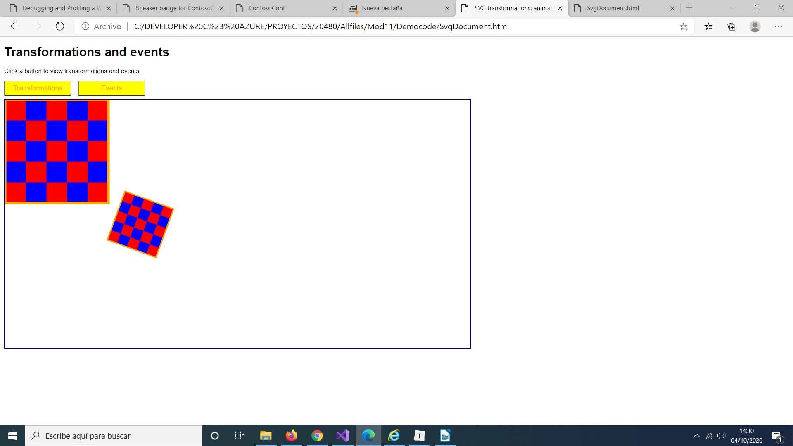

Transform SVG Elements
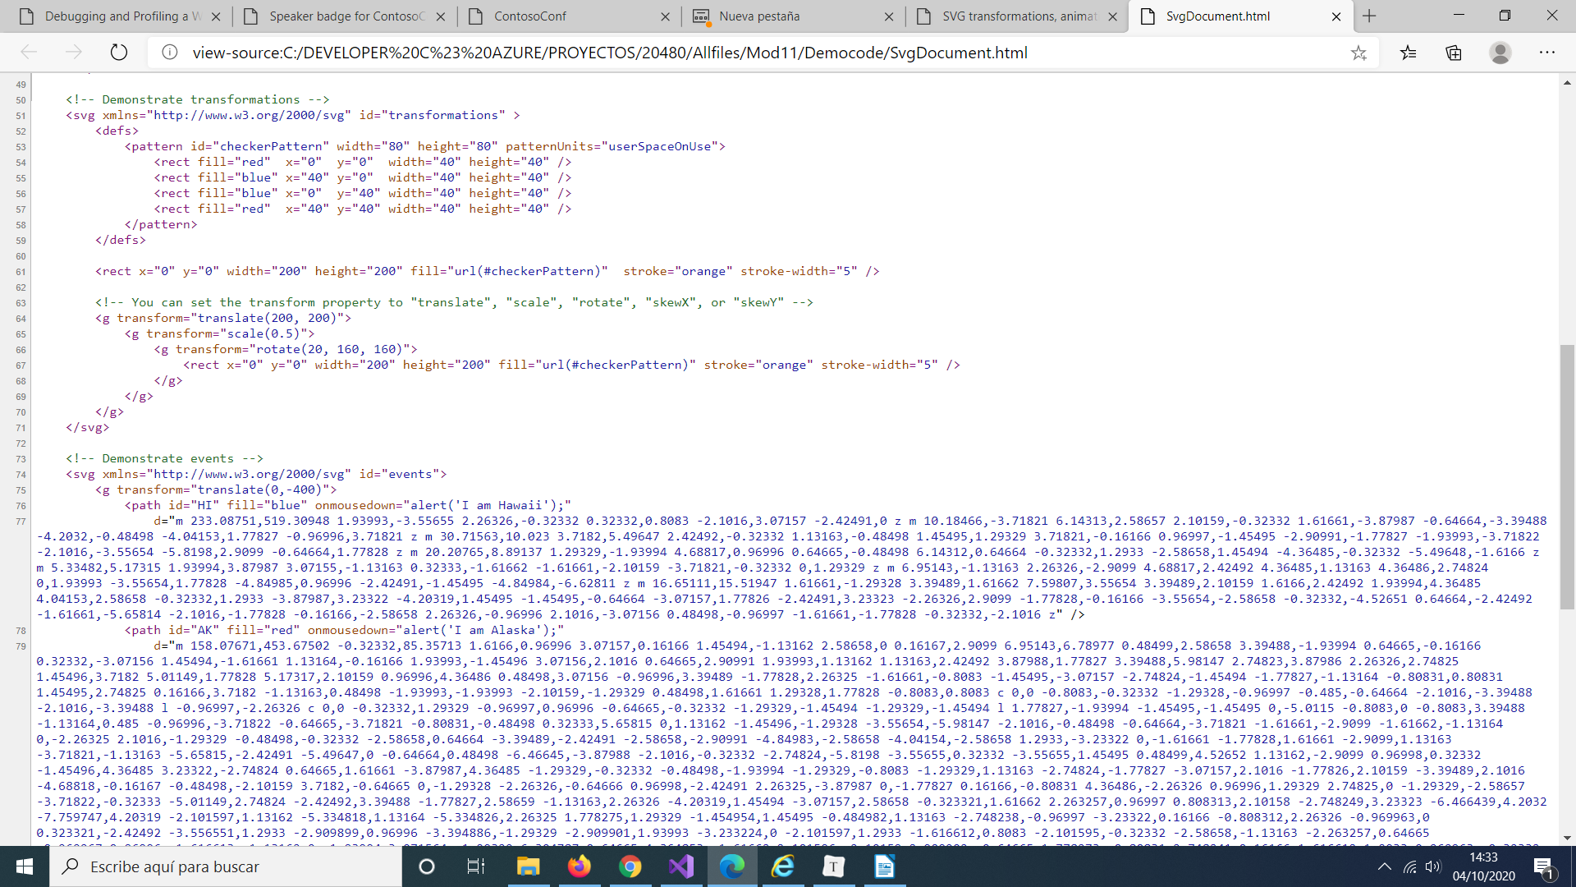

Handle Events on SVG Elements
SvgDocument.html
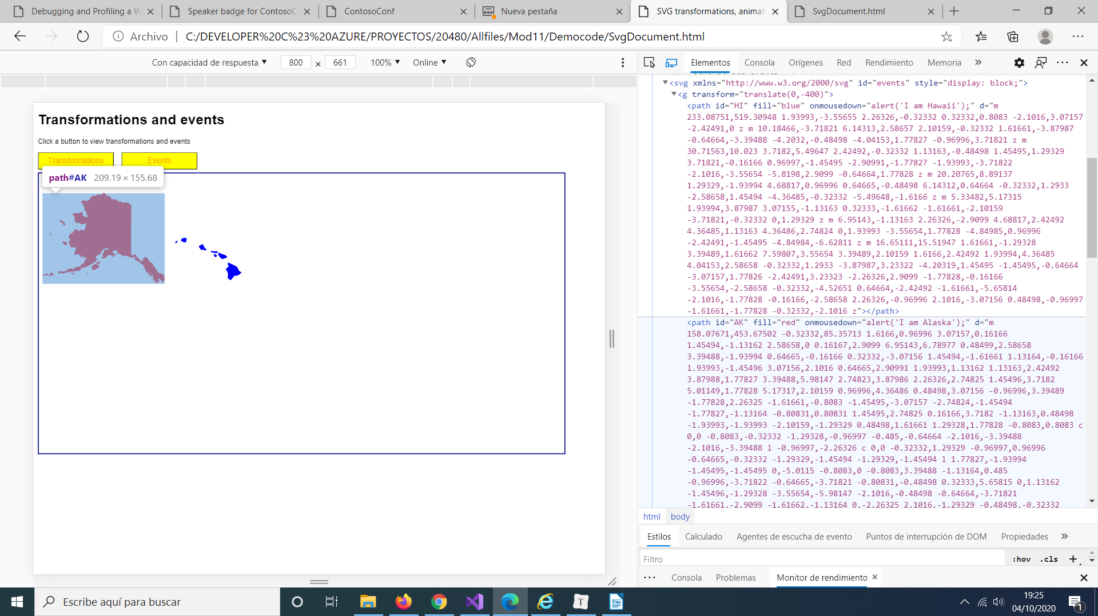
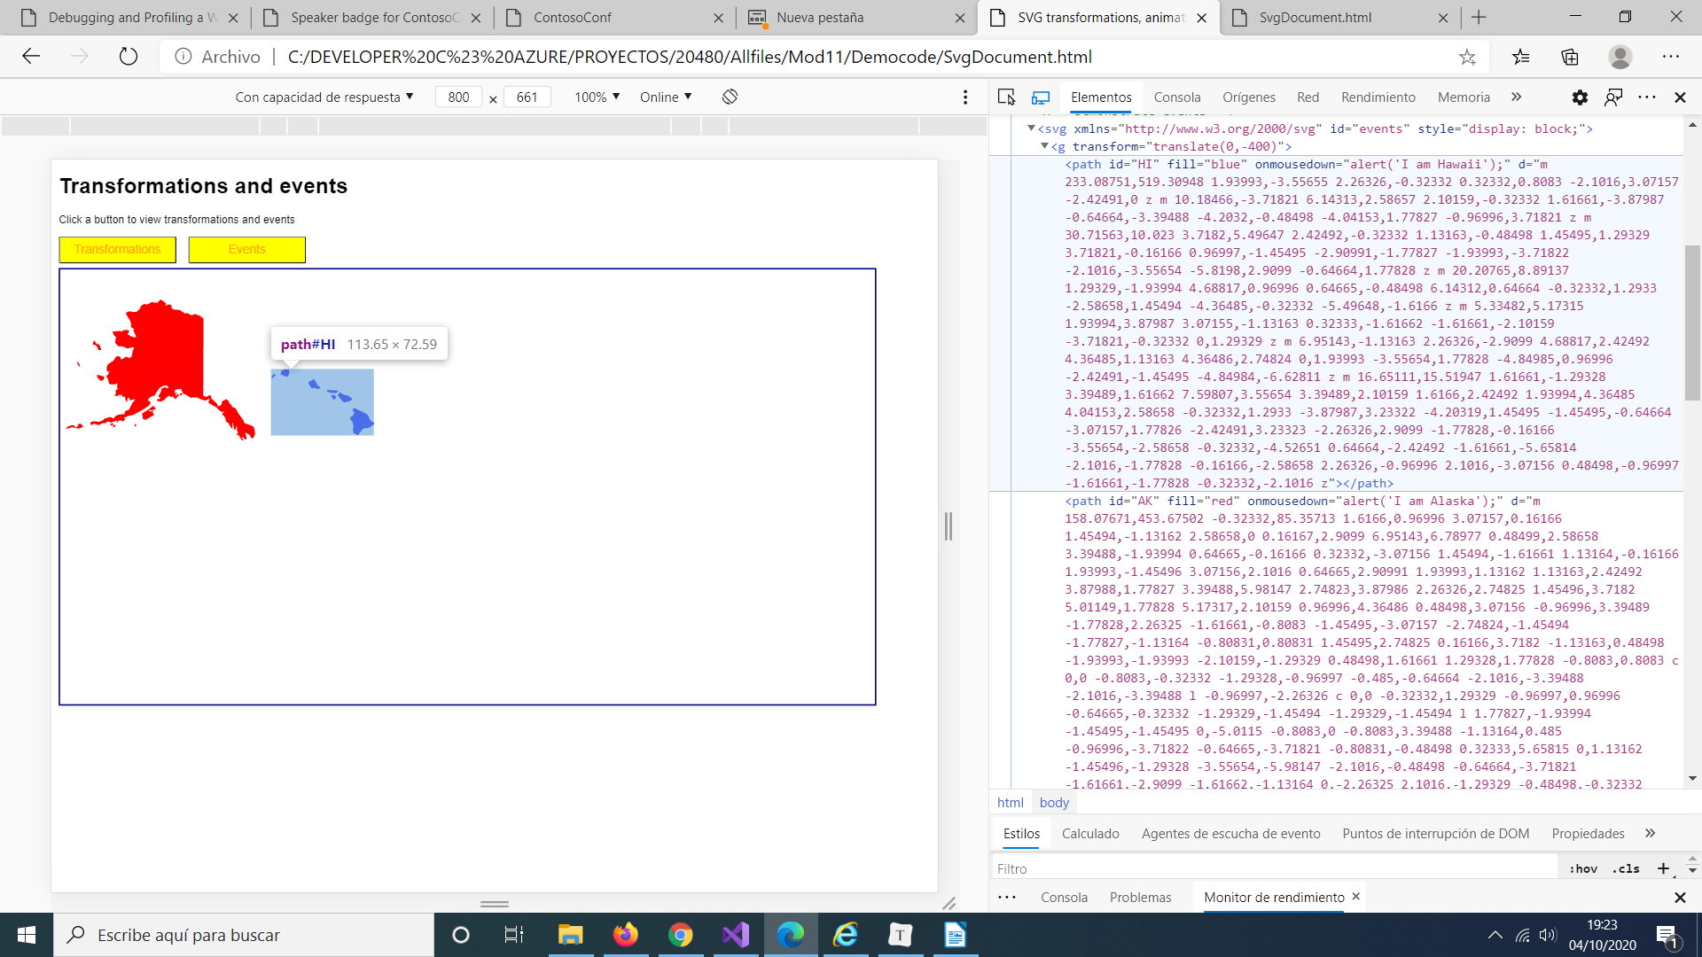
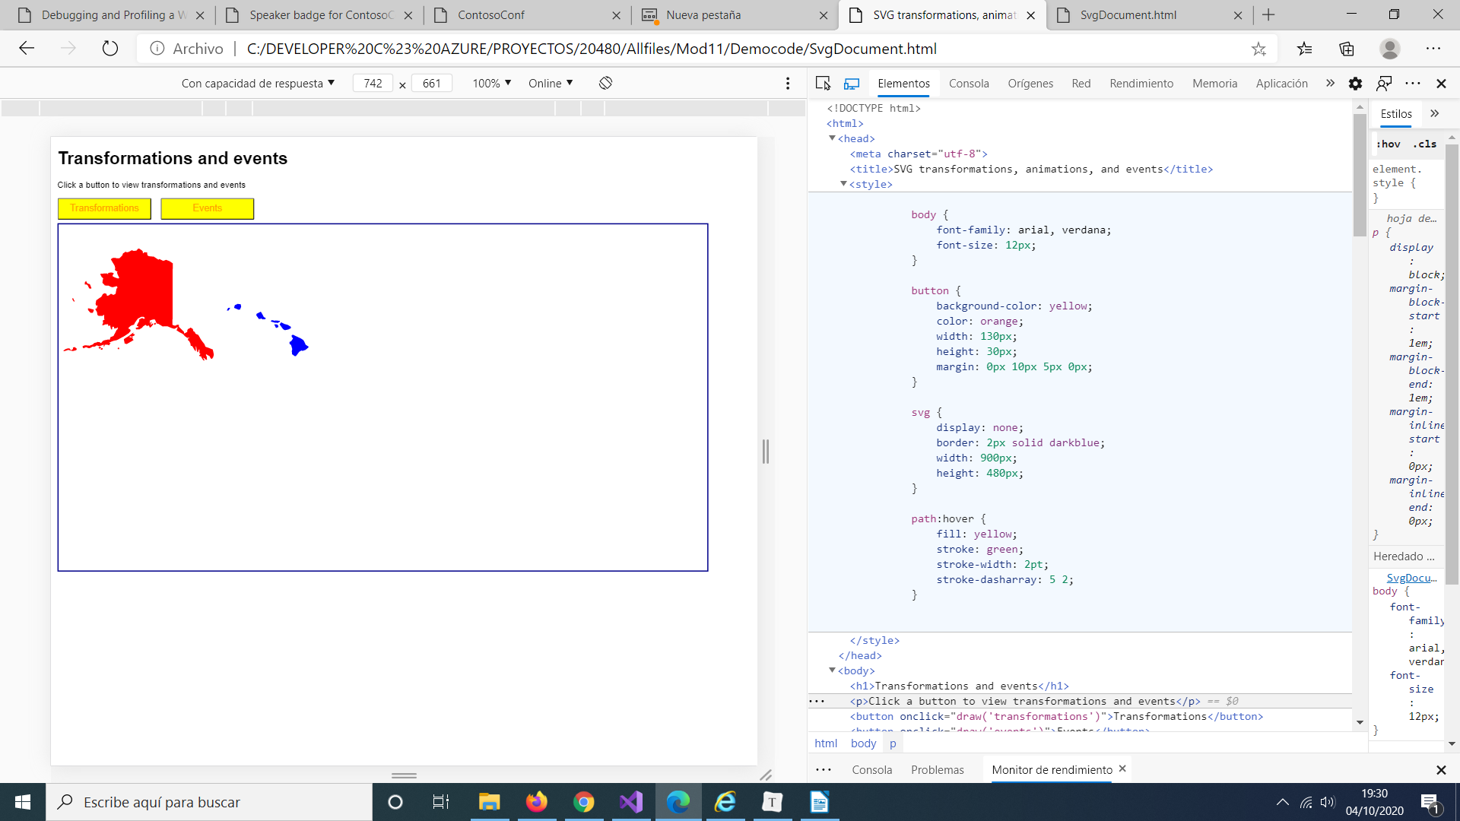

Lesson 2: Drawing Graphics by Using the Canvas API

Demonstration: Performing Transformations by Using the Canvas API

Perform Simple Transformations

CanvasDocument.html
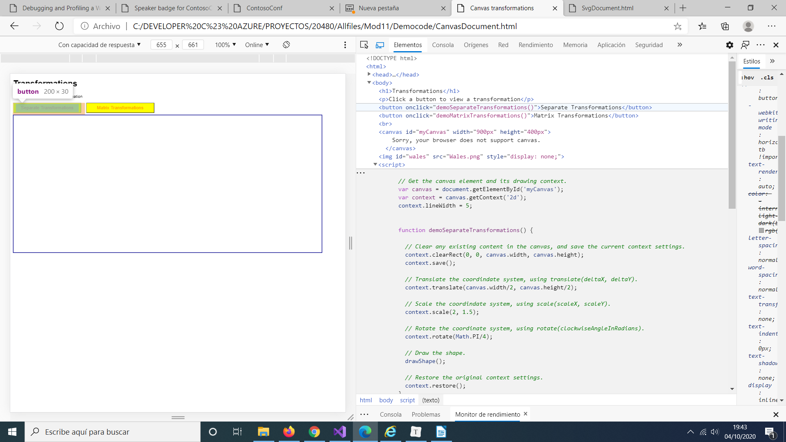
Perform Matrix Transformation
CanvasDocument.html
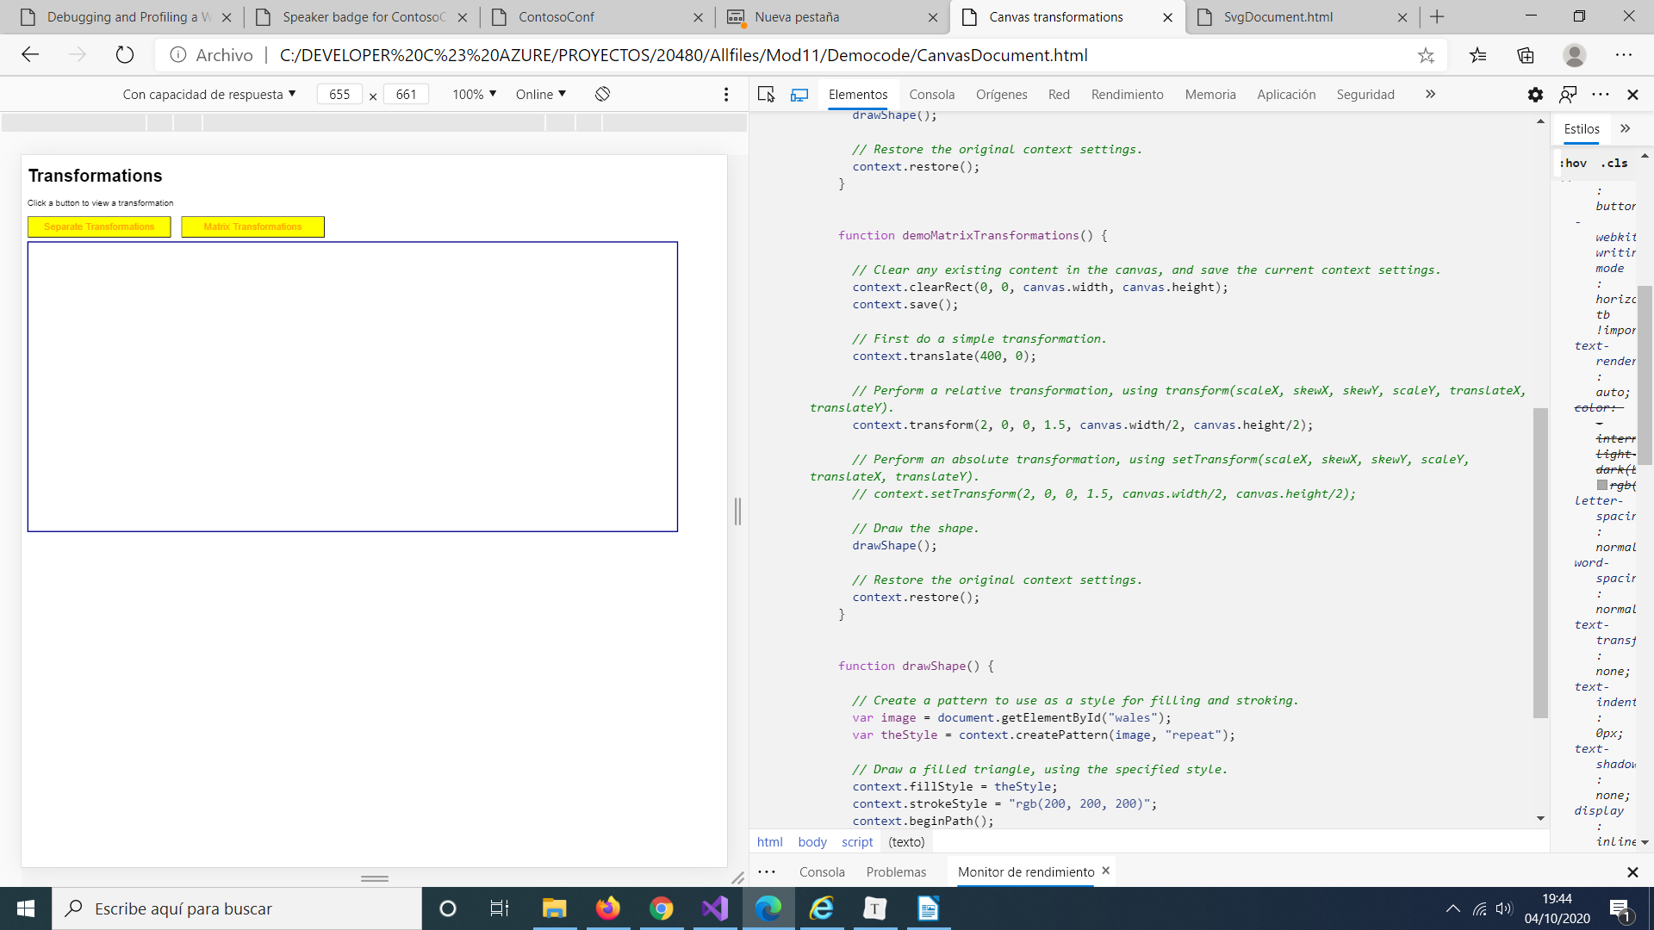
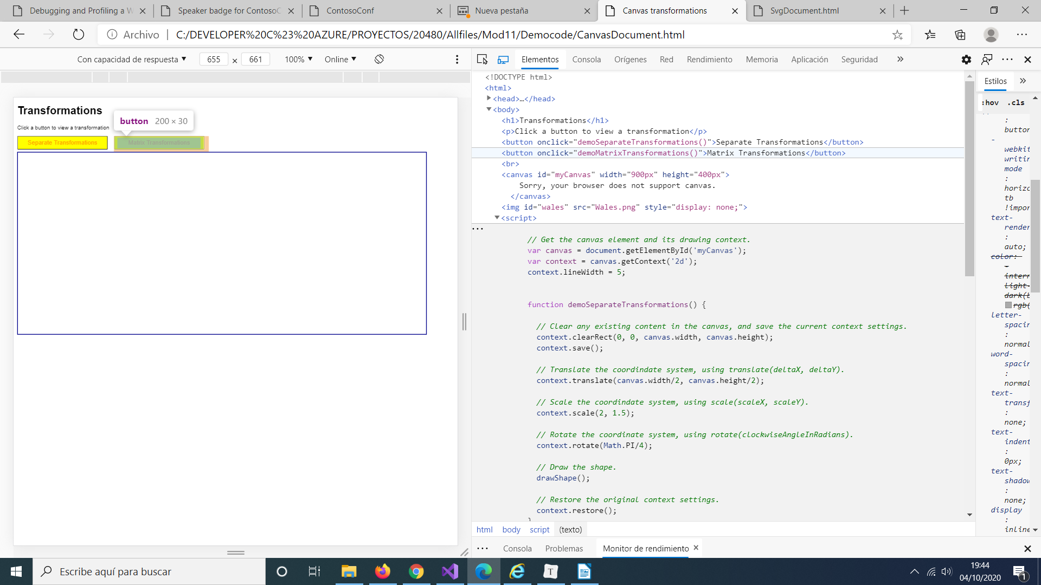

Demonstration: Creating Advanced Graphics
Local settings configuration
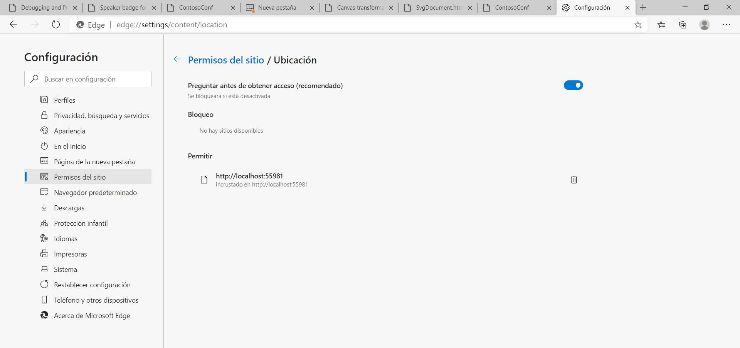
Location.htm
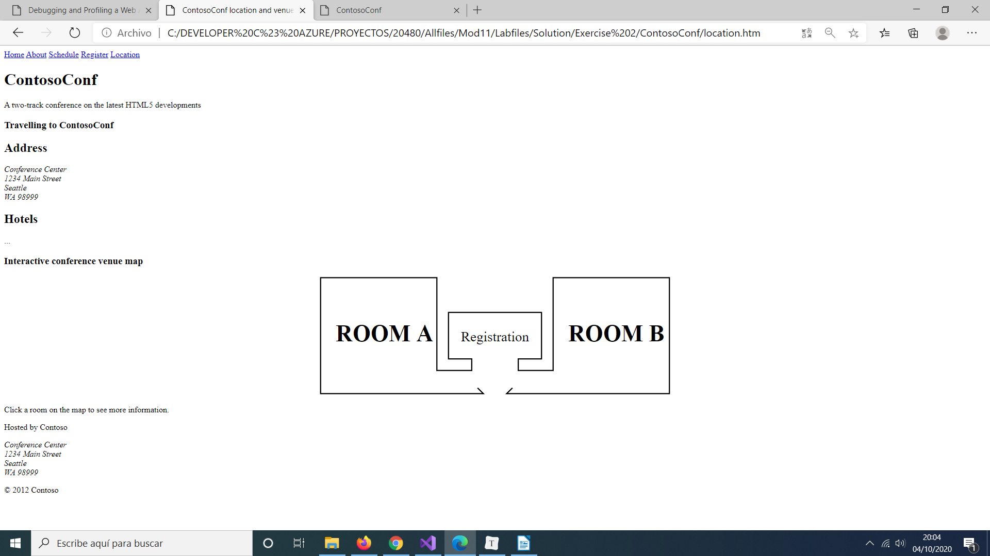

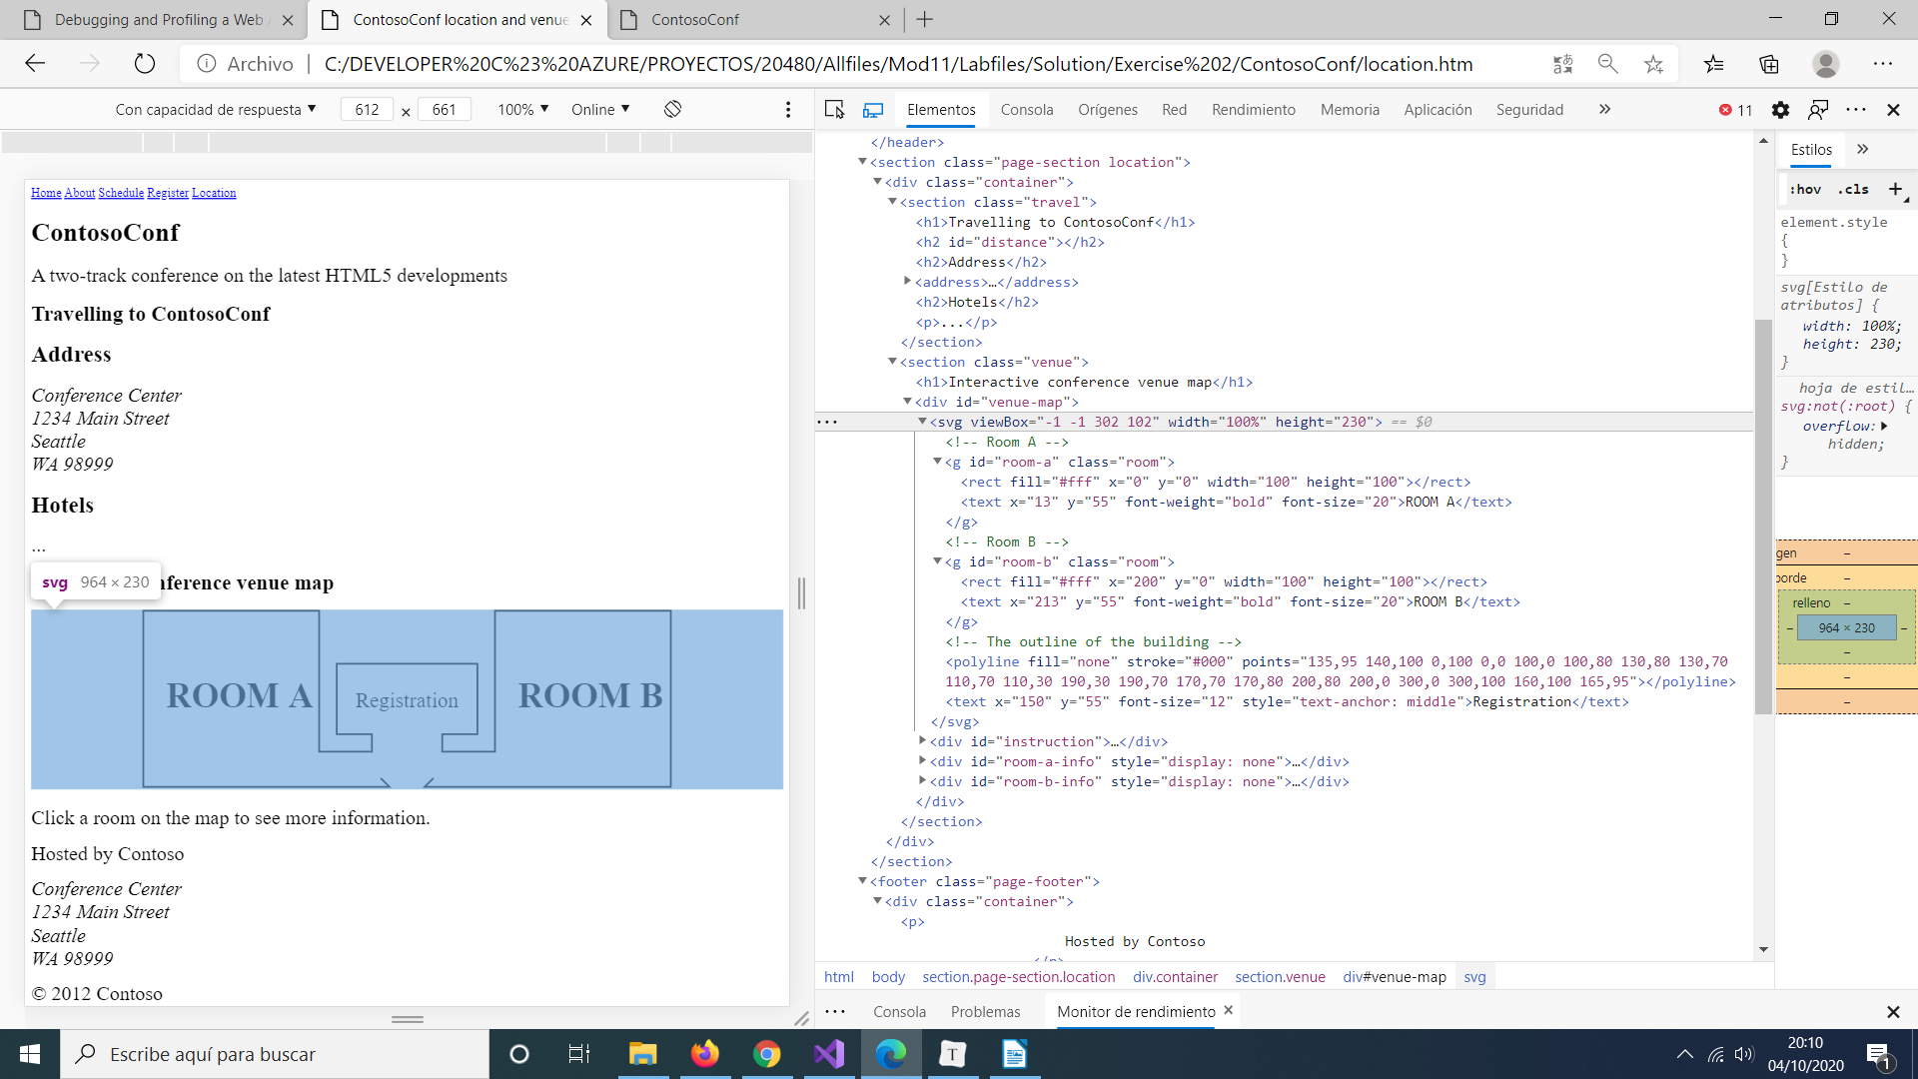
location-venue.js
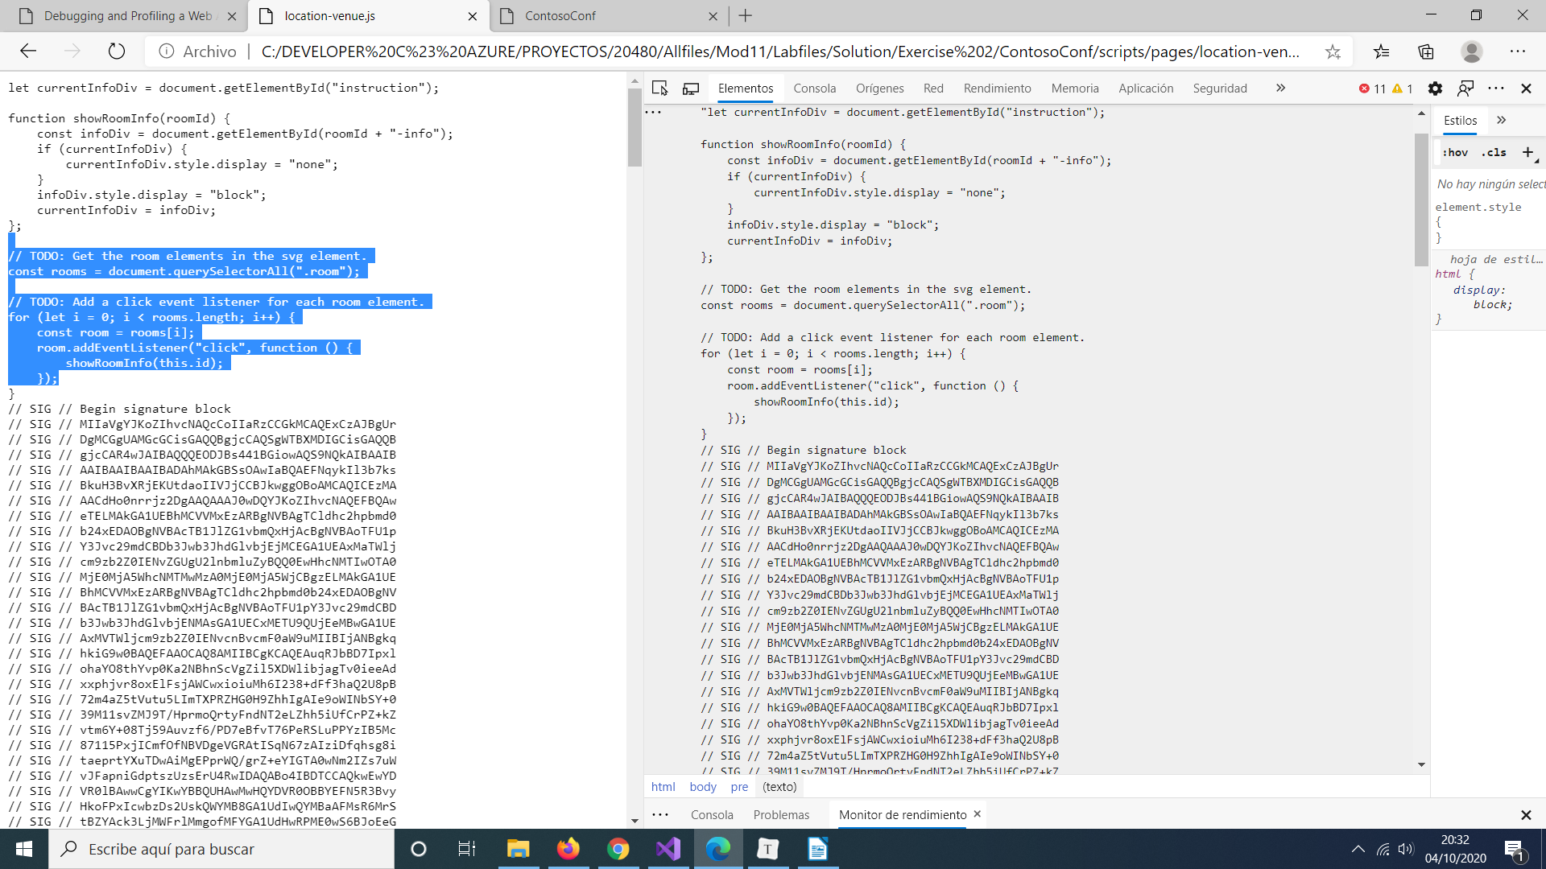
speaker-badge.htm
